**Dark and Light Theme Toggle**

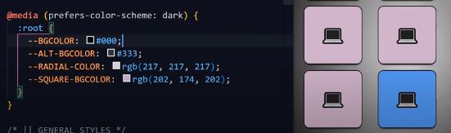

By using this media query prefers-color-scheme: dark it can change color based on the system theme